Software project management plan

Project Name：Cinema ticketing system based on Node.js

|  |  |
| --- | --- |
| Members： | Wang wenjing |
|  | Pan jiaqi |
|  | Chen minghui |

Date：2023.3.23

Contents

1 Introduction 1

1.1 Overview 1

1.2 Project delivery products 1

1.3 Evolution of software project plan 1

2 Project organization 2

3 Functional modules of the system 3

4 Management process 3

4.1 Management goals and priorities 3

4.2 Risk management 4

4.3 Personnel plan 5

4.4 Study plan 6

5 Technical process 6

5.1 Develop tools, methods and techniques 6

5.2 Documentation for software delivery 7

6 Development schedule 7

## 1 Introduction

### 1.1 Overview

This project aims to develop a simple cinema ticketing system. With the continuous improvement of people's living standards, people's lifestyles are no longer limited to the improvement of ordinary clothing, food, housing, transportation and other material aspects, but also pursue a qualitative mutation in the spiritual aspect. As a result, people increasingly choose to watch a movie with three or two friends on weekends or holidays to enjoy free time and release stress. In response to this demand of the public, many movie ticket purchase mini programs were born.

the cinema management department, ticket booking is the most basic business in all business, on the surface, it is only a simple part of the cinema business, but it involves management and customer service and many other aspects. However, in the past, the traditional way of purchasing tickets in cinemas can no longer meet everyone's requirements, which requires a new way to purchase tickets - online tickets, to relieve the pressure of peak periods and provide users with convenient and fast ways to purchase tickets.

### 1.2 Project delivery products

1）Submit documents: project management plan, plan report PPT, test report.

2）Source program check: Check the operation of each module, check the operation of the entire system, and submit the program source file and executable system after the check is completed. Program checks are scheduled to take place during start-up time.

### 1.3 Evolution of software project plan

The software project plan is formed into a preliminary draft through three steps of group discussion, co-writing, summary and integration, which can be revised according to the progress of the project, and needs to be proposed by team members, discussed and approved at the meeting, and the team leader will sort out the modification opinions and make corresponding modifications. The rest of the group members get the update at the same time.

## 2 Project organization

The member organizations are shown in the table.

|  |  |  |
| --- | --- | --- |
| Members | Roles | Responsibilities |
| Wang wenjing | Front-end development engineer, Test engineer | Mainly responsible for product page and user experience design, product testing. |
| Pan jiaqi | Product manager, Back-end development engineer | Responsible for researching market demand, ensuring product functions and features, responsible for back-end development and database management. |
| Chen minghui | Project Manager, Operation and maintenance Engineer | Responsible for the planning, organization, implementation and control of the project, as well as the deployment and maintenance of the product. |

## 3 Functional modules of the system

The functional modules of the system are mainly divided into four parts: home, address, discovery, and me. WeChat users can browse the recommended movies on the homepage, the basic information of the movie, and then purchase tickets after confirmation. View the address information of the theater on the address page, click the location of the theater that will appear, you can open the navigation software in the mobile phone to view the specific route, and the surrounding basic information. There are clips and basic information about popular movies on the discovery page, and users can watch the clips to determine whether they like the movie or not. My Page performs functions such as Mini Program user login, registration, logout login, and order viewing.

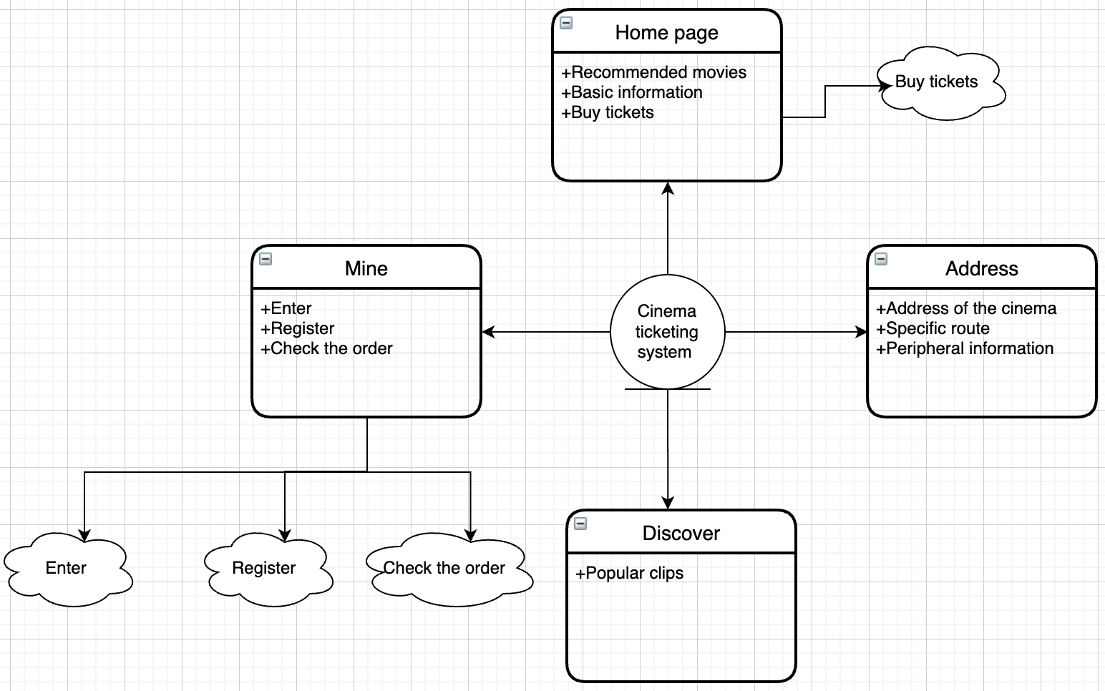

## 4 Management process

### 4.1 Management goals and priorities

Basic management principle: Each team member is both an active advisor, a responsible collaborator, and a decision-maker. Decisions should be made jointly by all on the basis of full discussion and must be implemented in a timely and effective manner once they are made. No further objections are prohibited.

Goal 1: Complete the basic functions of the project on time and in quantity, and release products and documents on time, which is the highest goal of the team.

Goal 2: Follow the standardized project operation standards, rigorous and complete documentation, sufficient code comments, and facilitate subsequent maintenance, which is the second goal.

Goal 3: The product runs stably, the interface is friendly, the user is easy to operate, try to see the problem from the user's point of view, and propose a solution to the problem.

Goal 4: Pay attention to team building, reasonable division of labor, tacit cooperation among team members, and harmonious atmosphere. Weekly seminars are positive. Actively collaborate during development.

### 4.2 Risk management

There are the following risks in this development process:

1、Skilled development technology is not enough.

2、Lack of adequate art support.

3、Due to the tight schedule, the project could not be completed on time.

avoidance methods:

1、The team's lack of proficiency in development tools and techniques can have a disastrous impact on the entire project. Therefore, in order to minimize the risk, we decided to make a one-week study plan in advance, and systematically learn about the development tools and development environment.

2、Due to the lack of art technology, the interface is not friendly, so we will study UI design in depth and actively seek foreign help.

3、If an extension is necessary, the group leader should explain it to the teacher in time and apply for an extension.

### 4.3 Personnel plan

Project manager：Chen minghui

Responsible for the planning, organization, implementation and control of the project, coordinate the work among the project team members, manage the progress and quality of the project, and ensure that the project is completed on time and according to quality.

Product Manager：Pan jiaqi

Responsible for investigating market demand, determining product functions and features, writing requirements documents and product plans, supervising the progress in the product development process, and ensuring that product development meets market demand and user needs.

Front-end development engineer：Wang wenjing

Responsible for the design of product interface and user experience, familiar with Node.js module design, including visual design and interaction design, etc., to ensure that the product interface and user experience meet user needs and design standards.

Back-end development engineer：Pan jiaqi

According to product requirements and design, responsible for software or hardware development, testing, deployment and maintenance, including back-end development, database management and other work.

Test Engineer：Wang wenjing

Responsible for testing products, finding and reporting defects and problems in products, ensuring the quality and reliability of products.

Operations Engineer：Chen minghui

Responsible for product deployment, maintenance, monitoring and optimization to ensure stable operation and high availability of products.

### 4.4 Study plan

Node.js module：Learn how to use the Node.js module system, including how to import and export modules, and how to create your own modules.

Learning objects：Wang wenjing、Pan jiaqi、Chen minghui

Asynchronous programming：To adopt the asynchronous programming model, it is necessary to master asynchronous programming technologies such as callback functions, event-driven programming, Promises, and async/await.

Learning objects：Wang wenjing、Pan jiaqi、Chen minghui

HTTP services and routing: Learn how to create HTTP servers and routes using Node.js, and how to handle HTTP requests and responses.

Learning objects：Wang wenjing、Pan jiaqi、Chen minghui

Databases: Learn how to use Node.js connect and learn SQL statements and how to manipulate databases such as MySQL.

Learning objects：Wang wenjing、Pan jiaqi、Chen minghui

WXML+WXSS: Learn WXML templates, WXSS styles, and JS logical interactions such as tags, elements, and attributes. Learn the basic syntax of JS, the framework of small programs, and basic components.

Learning objects：Wang wenjing、Pan jiaqi、Chen minghui

## 5 Technical process

### 5.1 Develop tools, methods and techniques

Team organizational structure: main programmer organizational structure;

Programming language: JavaScript;

Adopt unified JavaScript standard file naming methods, code layout, comments and other coding specifications;

Integrated development environment: WeChat developer tools;

Design methodology: object-oriented;

Database：MySQL；

Database management tools：SQLyog.

### 5.2 Documentation for software delivery

1）Software project management plan

This document is completed by the team leader and describes the entire management process of the project. This documentation is completed in the initial phase of the software design requirements analysis, and the subsequent stages are updated accordingly by the documentation maintainer.

2）Test documentation

During the software development phase, testers need to write test specification documents.

3）Instructions for use

Procedure instruction manual.

## 6 Development schedule

1、Preparation phase

Date：2023.03.10-2023.03.30

This stage includes: formulating the plan and task book, knowledge reserve, setting up the development environment, and collecting and processing data.

2、Development phase

Date：2023.03.31-2023.04.20

This stage is the most important stage, creating training and test data, building mini programs, predicting reactions, front-end and back-end design, code debugging, and finally being able to submit a demo.

3、Assessment phase

Date：2023.04.21-2023.05.11

This stage is the risk assessment, software testing and modification phase to ensure that the project can be perfectly realized.

4、Optimization phase

Date：2023.05.12-2023.06.01

Optimize projects, optimize artwork, and improve user experience.

5、Acceptance phase

The software is delivered, and the whole system can run successfully and stably.